Spike Exercise1 Rate Em

Installed Android SDK plugin for Eclipse from <http://developer.android.com/sdk/index.html>

Followed the my first app tutorial from

<http://developer.android.com/training/basics/firstapp/index.html>

successfully finished the tutorial

Created a new app project in eclipse

Working on getting the button “Create New Account” to switch over to another page within the app. Have looked and use partial code from the following sources (places where code was used is commented for citation.

<http://stackoverflow.com/questions/14207392/android-button-click-go-to-another-xml-page>

http://developer.android.com/training/basics/firstapp/starting-activity.html

Once completing the Create New Account button code the app would not push over to my phone (which was my testing environment) and thus could not see if my changes worked. I also tried using the emulator and the app would not load on the emulator as well.

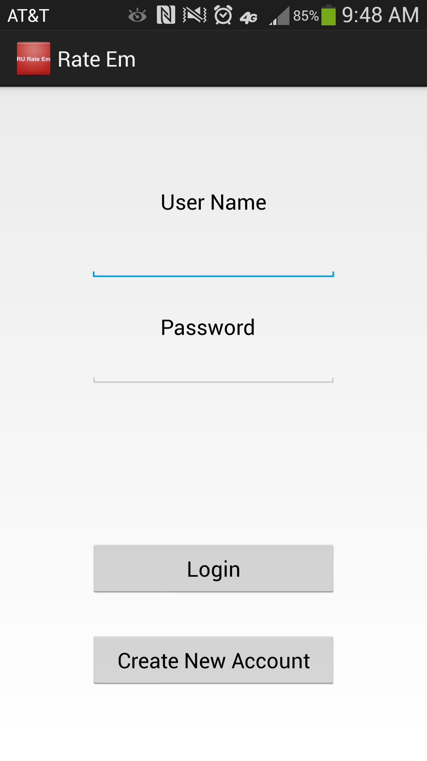

This is the starting screen for the app when it first loads. User name field and a password field (the password field is set to hide the characters you type in to keep your password safe). The Login button is used to login with valid credentials (does not work) and the create new button takes you to another page to create an account (does not work see above)